Project Design Phase-II

Technology Stack (Architecture & Stack)

|  |  |
| --- | --- |
| Team ID | PNT2022TMID04782 |
| Project Name | Real Time River Water Quality Monitoring and Control System |
| Maximum Marks | 2 Marks |

Technology architecture:

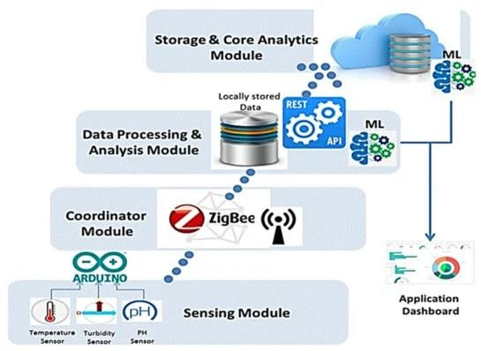

Components & Technologies:

|  |  |  |  |
| --- | --- | --- | --- |
| S. No | Components | Description | Technology |
| 1. | Turbidity sensor | Turbidity probe works by sending a light beam into the water to be  tested. | TI CC3200  Launch |
| 2. | pH sensor | pH sensor helps to measure the acidity or alkalinity of the water. | Smart phone |
| 3. | Conductivity sensor | Used in water quality application to measure how well a solution conducts an electrical  current. | WI-FI module |